Report on website design project (<https://bruce-kirwan.github.io/StarLife/>)

Author: Bruce Kirwan

Submission Date: August 2019

Course: Level3 Programming in HTML5 with JavaScript and CSS3 (4520-635)

Assignment A, Part 1: Website Design Project

# Description:

This document describes the project plan, user requirements, sitemap, wireframe, COMPs and testing plan for the Website Design Project.

# Table of Contents

# Introduction

# Project Plan

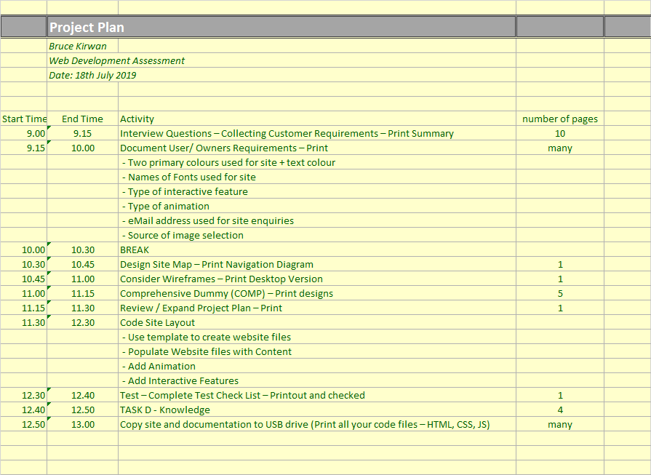

# User Requirements

# Sitemap:

The navigation diagram shown below illustrates the navigation structure of the website.

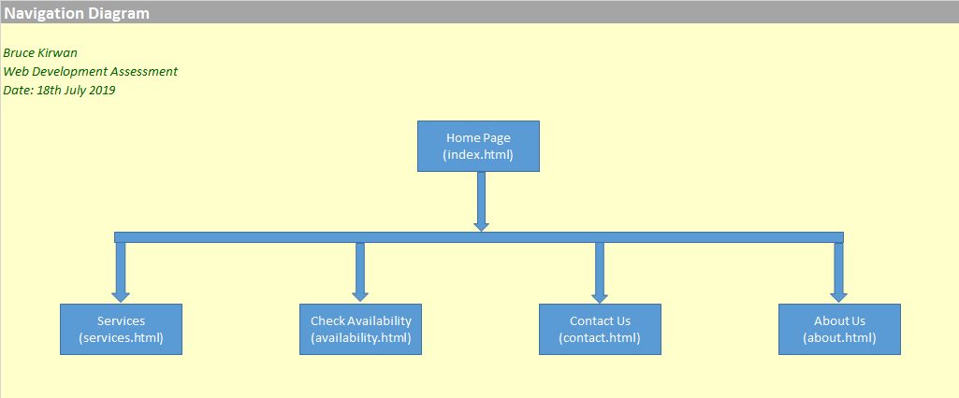

My website consists of 5 pages.

The home page (index.html) links to each of the other pages.

You can access any page from each other internal page by clicking on the link in the navigation menu.

The navigation menu appears on the top of the webpage for larger screen views (greater than 600 pixels).

The navigation menu appears in mobile view when the hamburger menu in the top right is clicked on.

# Wireframe Designs

## WireFrame Design of the webpage in small screen view:

Below is the wireframe diagram for smaller screens (less than or equal to 600 pixels.

It is intended for smartphones, smaller tablets etc.

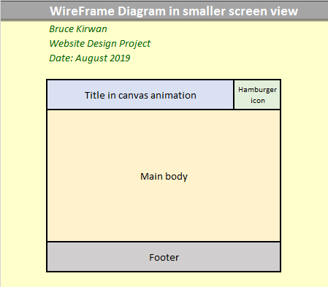

## Wireframe Design of the webpage in large screen view:

Below is the wireframe for larger screens (greater than 600 pixels wide).

It is intended for when viewing on a PC, laptop or larger tablet.

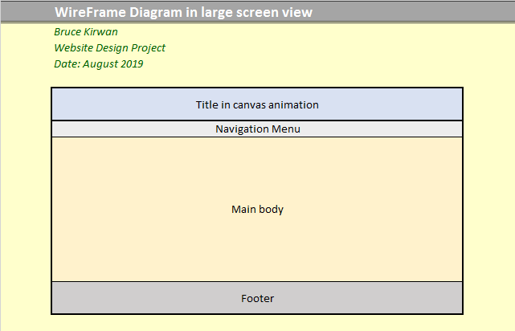

# Web Design Comprehensives (COMPs)

These are mock-ups of the intended design

## COMP for home page in larger view:

Intended design is as below:

|  |  |  |  |  |  |  |
| --- | --- | --- | --- | --- | --- | --- |
| Star Life Technologies | | | | | | |
|
| Home | Services | Check Availability | | Contact Us | | About Us |
| **Star Life Technologies** | |  | | | Location |  |
| **services** |  | Telephone |  |
| CCTV |  | E-mail |  |
| Network install | |  |  |
| Operating System | |  |  |
| Helpdesk |  |  |  |
|  |  |  |  |
|  |  |  |  |  |  |  |
|  |  |  |  |  |  |  |
|  |  |  | Website Details | |  |  |
|  |  | Time spent on site **15** seconds | | |  |  |

## Comp for Homepage in mobile view:

Intended design as below:

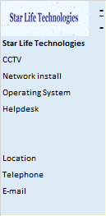

## COMP for services page in larger view:

Intended design is as below:

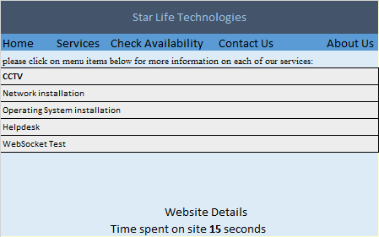

## COMP for availability page in larger view:

Intended design is as below:

|  |  |  |  |  |  |  |
| --- | --- | --- | --- | --- | --- | --- |
| Star Life Technologies | | | | | | |
|
| Home | Services | Check Availability | | Contact Us | | About Us |
|  |  |  |  |  |  |  |
|  |  |  | September 2019 | |  |  |
|  | Mon | Tues | Wed | Thurs | Fri |  |
|  |  | 1 | 2 | 3 | 4 |  |
|  | 7 | 8 | 9 | 10 | 11 |  |
|  | 14 | 15 | 16 | 17 | 18 |  |
|  | 21 | 22 | 23 | 24 | 25 |  |
|  | 28 | 28 | 30 | 31 | 1 |  |
|  |  |  |  |  |  |  |
|  |  |  | Website Details | |  |  |
|  |  | Time spent on site **15** seconds | | |  |  |

## COMP for contact page in larger view:

Intended design is as below:

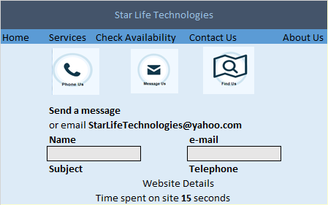

## COMP for about page in larger view:

Intended design is as below:

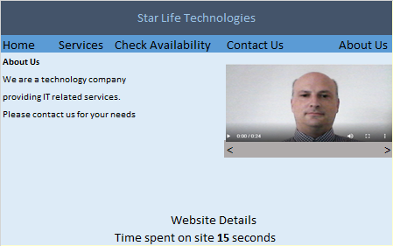

# Testing Plan

